Issues on Bid Submission (2026-03-19)
- Should allow uploading document in the proposal/ cover letter
-“Timeline” should be renamed as “Expected turnover time”
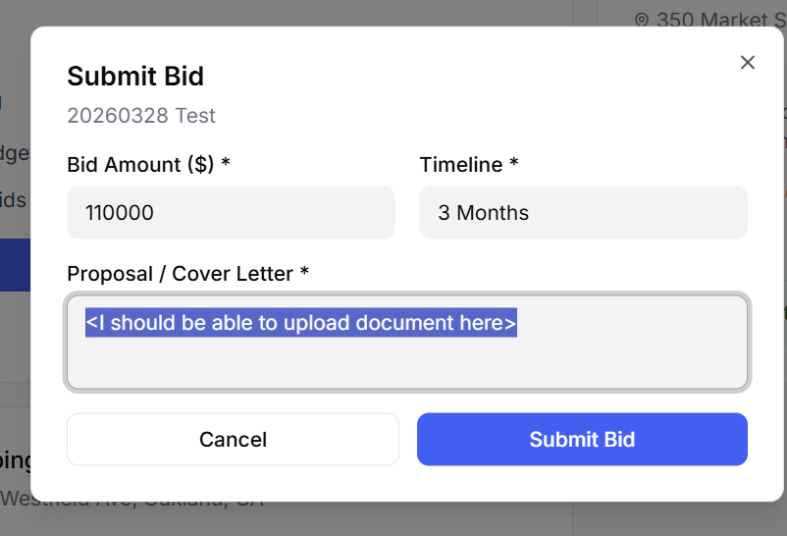
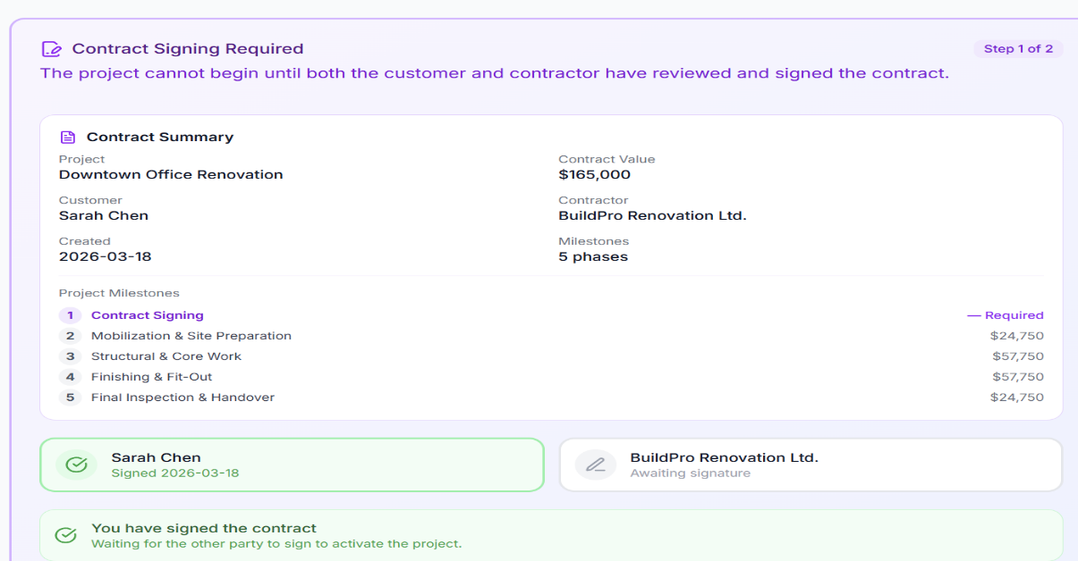
Issue on Bid Acceptance (2026-03-19)

- On signing of contract, instead of just clicking the button of sign, we should implement two-factor authentication as it is a material transaction.
- Upon signing, the time of signing should also be specified
- For the payment arrangement, where can customers see or set specific payment arrangement? Seems that in the bid marketplace, neither customer or decoration company can see the arrangement in advance
Issue on Milestone Review
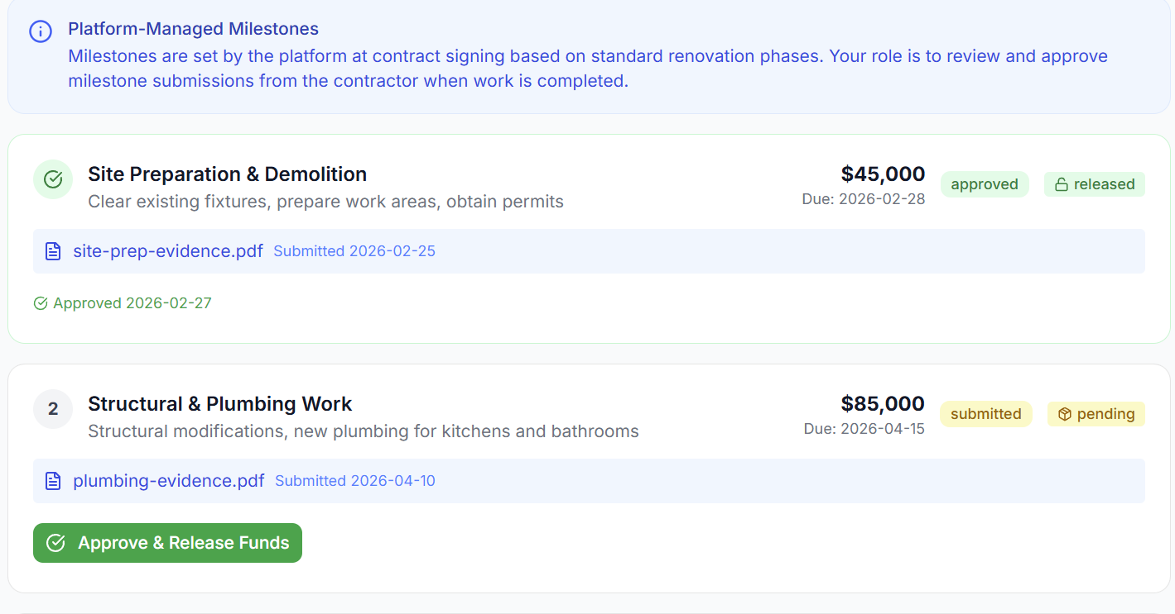
- Not able to read the plumbing-evidence
- Raise dispute button should be put next to approve & release funds
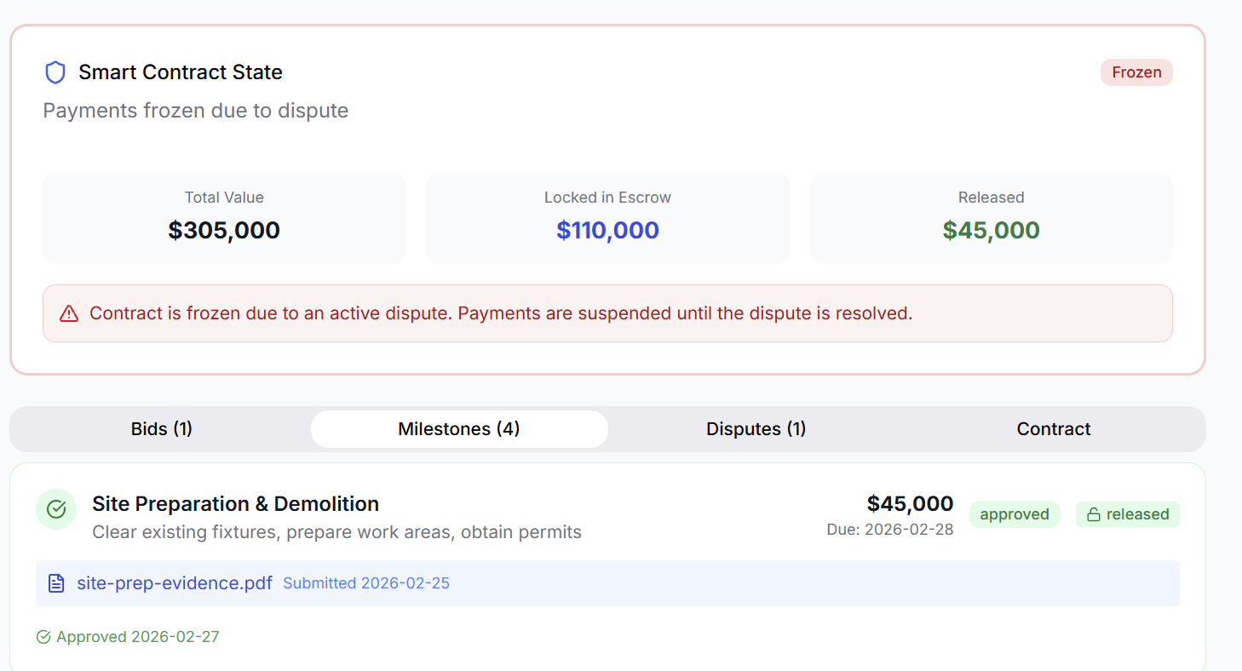
- Even if the Site Preparation & Demolition has been approved and payment released, I could still raise dispute when selecting the button on the right hand corner -> the whole page will be frozen “due to acting dispute”
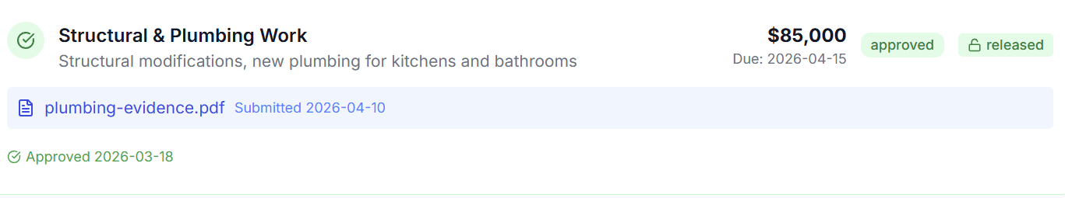
- For approve payment, user just need press the button once, without requiring to enter any password or two factor authentication. User may make mistake and click the button wrongly. If no second thought is allowed, the payment will be released and cannot be reverted.

